Two-Factor Authentication (2FA) Verification

🔐 What is Two-Factor Authentication (2FA) Verification?
# Source: Chatgpt (GPT-5-Mini) at [1/20/2026]
Two-Factor Authentication (2FA) is a security process where users must provide two different types of verification to access their account. This reduces the risk of unauthorized access, even if the password is compromised.

🧩 How 2FA Works
# Source: Chatgpt (GPT-5-Mini) at [1/20/2026]
2FA combines:
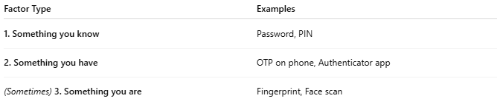
Factor Type | Examples
1. Something you know | Password, PIN
2. Something you have | OTP on phone, Authenticator app
(Sometimes) 3. Something you are | Fingerprint, Face scan

🔁 2FA Login Example
# Source: Chatgpt (GPT-5-Mini) at [1/20/2026]
- 🧑 User enters username and password.
- ✅ If correct, system sends a verification code (OTP):
  - SMS
  - Email
  - Authenticator app (like Google Authenticator)
- 🔐 User enters that OTP.
- ✅ If the OTP is valid and not expired → Access is granted.

📱 Common 2FA Methods
# Source: Chatgpt (GPT-5-Mini) at [1/20/2026]
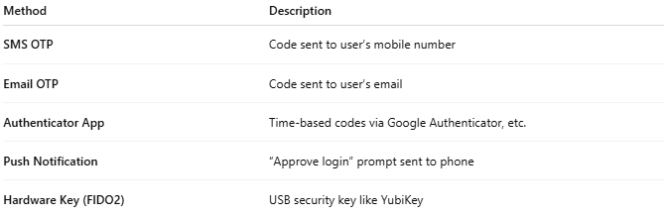

Method | Description
SMS OTP | Code sent to user’s mobile number
Email OTP | Code sent to user’s email
Authenticator App | Time-based codes via Google Authenticator, etc.
Push Notification | “Approve login” prompt sent to phone
Hardware Key (FIDO2) | USB security key like YubiKey

🔐 Why 2FA Is Important
# Source: Chatgpt (GPT-5-Mini) at [1/20/2026]
✅ Protects against:
- Password leaks
- Phishing
- Brute-force attacks

📦 APIs to Add 2FA in Your App
# Source: Chatgpt (GPT-5-Mini) at [1/20/2026]
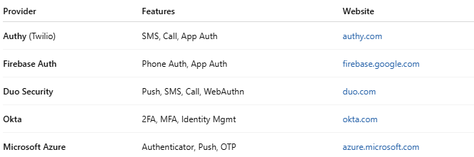

Provider | Features | Website
Authy (Twilio) | SMS, Call, App Auth | authy.com
Firebase Auth | Phone Auth, App Auth | firebase.google.com
Duo Security | Push, SMS, Call, WebAuthn | duo.com
Okta | 2FA, MFA, Identity Mgmt | okta.com
Microsoft Azure | Authenticator, Push, OTP | azure.microsoft.com

✅ Simple Flow (SMS-based 2FA in PHP):
# Source: Chatgpt (GPT-5-Mini) at [1/20/2026]
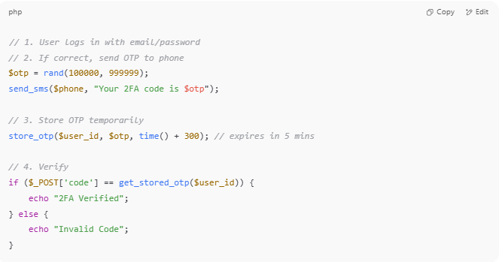

// 1. User logs in with email/password
// 2. If correct, send OTP to phone
$otp = rand(100000, 999999);
send_sms($phone, "Your 2FA code is $otp");

// 3. Store OTP temporarily
store_otp($user_id, $otp, time() + 300); // expires in 5 mins

// 4. Verify
if ($_POST['code'] == get_stored_otp($user_id)) {
echo "2FA Verified";
} else {
echo "Invalid Code";
}

